

13 January 2019

RE: Norman Mast
Letter or Recommendation

To Whom It May Concern:

I am gladly writing in reference, at the request of Norman Mast, who is a long-serving adjunct colleague in the Angell Snyder School of Business. I have known Norm since September, 2000. He currently holds the position of Part-time Faculty. His duties include teaching management, project management and supply chain management courses.

Norm is distinctly known for his teaching talents, specifically his ability to translate complex managerial concepts into easy to understand terminology. He is also known for his ability to interact across multiple constituencies, making everyone feel at ease. He teaches in three locations for the university, the Overland park campus, The College, and Online. In all cases, his students give him only the highest reviews and lobby for his return semester after semester.

Norm is an active and conscientious member of the Ottawa University faculty. He challenges his classes to consider issues from new perspectives and routinely asks very penetrating and important questions. He has also chosen to take on difficult topics and handles them well. Norm is highly regarded by both our students and his colleagues. He is considered challenging, but also kind. He strives to ensure our students are recognized as individuals, and that they get the one-on-one support they need to go beyond what they think they can achieve in his courses.

In short, I give Norman Mast my highest recommendation; Ottawa University is privileged to have him as an adjunct faculty member at our institution. Please don’t hesitate to contact me if you need further information regarding Norm.

Regards,

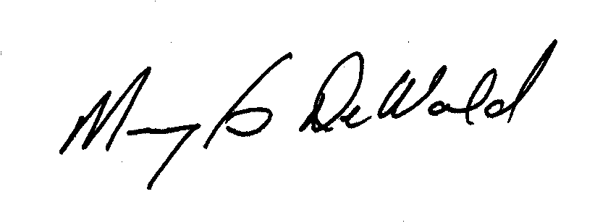
Dr. Marylou DeWald
Dean, Global Initiatives
Division Chair, Business & Public Policy
Professor, Angell Snyder School of Business - Business Administration

